SCHOOL OF PHARMACY |  | 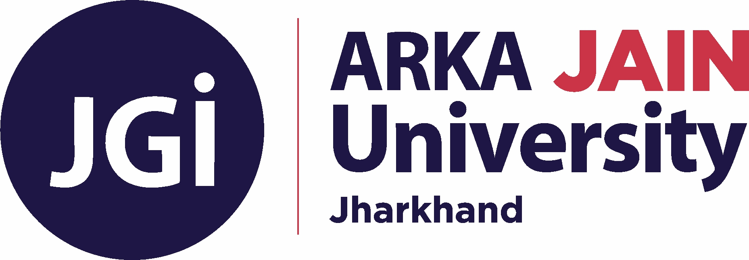 |  |  | 1ST INTERNAL EXAMINATION
Program Name |  | BACHELOR OF PHARMACY | Program Code |  | B.PHARM
Course Name |  | PHARMACEUTICS I | Semester |  | 1st Semester (Group-D)
Course Code |  | PHM21009 | Year |  | 2023/Odd
Time: 4 Hours |  | All the Questions are COMPULSORY | Maximum Marks |  | 40
Knowledge Level (KL) |  | K1 : Remembering | K3 : Applying |  | K5 : Evaluating
 |  | K2 : Understanding | K4 : Analysing |  | K6 : Creating
Section A
[1 x 10 = 10 Marks]
Q. No. | Questions |  |  | Marks |  | COs | KL | PO
I | Synopsis  Write a note about the different liquid dosage forms. |  |  | 10 |  | CO1 | K1, K2, K3 | PO1
Section B
[25 Marks]
Q. No. | Questions |  |  | Marks |  | COs | KL | PO
II | Experiment  To prepare and dispense 10 ml of simple syrup IP. |  |  | 25 |  | CO1 | K3, K4, K5 | PO1
Section C
[05 Marks]
Q. No. | Questions |  |  | Marks |  | COs | KL | PO
III | Viva voce |  |  | 05 |  | CO1 | K5 | PO1

CO- Course Outcomes, KL- Knowledge Level, PO – Program Outcome
Course Outcomes | CO1 | Gain required hands-on experience to prepare simple monophasic oral liquid dosage forms
 | CO2 | Understand basic methods to formulate conventional powder dosage forms
 | CO3 | Understand the Perform experiments on bi-phasic oral liquid dosage forms
 | CO4 | Learn the techniques to formulate conventional semisolid dosage forms

