SCHOOL OF PHARMACY |  | 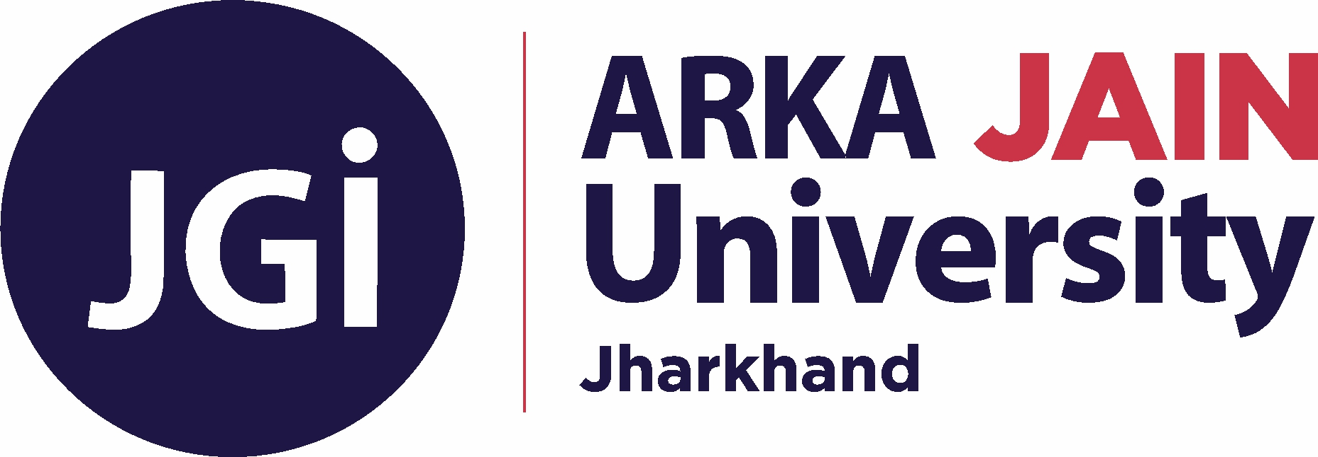 |  |  | 1ST INTERNAL EXAMINATION
Program Name |  | BACHELOR OF PHARMACY | Program Code |  | B.PHARM
Course Name |  | PHARMACEUTICS I | Semester |  | 1st Semester
Course Code |  | PHM21003 | Year |  | 2023/Odd
Time: 1 Hour |  | Answer all Questions of Section A  Answer Any one of Section B  Answer Any two of Section C | Maximum Marks |  | 30
Knowledge Level (KL) |  | K1 : Remembering | K3 : Applying |  | K5 : Evaluating
 |  | K2 : Understanding | K4 : Analysing |  | K6 : Creating
Section A
All the Questions are COMPULSORY
MULTIPLE CHOICE type Question [1 x 10 = 10 Marks]
Q. No. | Questions |  |  | Marks |  | Cos | KL | PO
1(i) | How many volumes have British Pharmacopoeia (BP)?  a) 4 b) 5  c) 6 d) 7 |  |  | 1 |  | CO1 | K1, K2 | PO1
1(ii) | Who is the father of Indian pharmacy?  a) Prof. M.L. Shroff b) Prof. T.K. Gujjar  c) Prof. B.N. Ghosh d) None of the above |  |  | 1 |  | CO1 | K1 | PO1
1(iii) | What is the full form of USP?  a) The United States Pharmacology  b) The United States Pharmacy  c) The United States Pharmacopoeia  d) The United States Pharmaceuticals |  |  | 1 |  | CO1 | K1, K4, K5 | PO1
1(iv) | What is the full form of Rx?  a) Take thou b) You take  c) a & b both d) None of the above |  |  | 1 |  | CO3 | K1, K2 | PO2
1(v) | A syrup is a concentrated aqueous solution of sugar present  a) 66.7% v/v IP b) 66.7% w/w IP  c. 66.7% w/v IP d) 66.7% v/w IP |  |  | 1 |  | CO2, CO4 | K1, K4, K5 | PO2
1(vi) | 100-degree proof alcohol  a) 57.1% v/v alcohol b) 57.1% w/v alcohol  c. 57.1% v/w alcohol d. None of the above |  |  | 1 |  | CO2, CO4 | K1, K4, K5 | PO2
1(vii) | Effervescent Powder contains  a) Sodium Bicarbonate + Citric acid  b) Sodium Bicarbonate + Tartaric acid  c) Citric Acid + Tartaric acid  d) Sodium Bicarbonate + Citric acid + Tartaric acid |  |  | 1 |  | CO4 | K2, K6 | PO2
1(viii) | Which of the following is not a solid dosage form?  a) Tablet b) Ointment  c. Capsule d) Powder |  |  | 1 |  | CO4 | K3, K4 | PO1
1(ix) | Which of the following is a biphasic liquid dosage form?  a) Syrup b) Lotion  c) Emulsion d) Elixir |  |  | 1 |  | CO4 | K3, K4 | PO1
1(x) | Elixir contains  a) Water b) Alcohol  c. Water & alcohol d. None of the above |  |  | 1 |  | CO4 | K3, K4 | PO1
Section B
Answer any ONE out of TWO [1x 10= 10Marks]
Q. No. | Questions |  |  | Marks |  | COs | KL | PO
1 | Give a detailed account about the pats of prescription |  |  | 10 |  | CO3 | K1, K2 | PO1
2 | Give a brief note on the liquid dosage solubility enhancement technique. |  |  | 10 |  | CO4 | K2, K3 | PO1
Section C
Answer any TWO out of THREE [2 x 5 = 10 Marks]
Q. No. | Questions |  |  | Marks |  | COs | KL | PO
1 | Write about the errors of prescription. |  |  | 05 |  | CO3 | K1, K2 | PO1
2 | Write a short on Indian Pharmacopoeia. |  |  | 05 |  | CO1 | K1, K2 | PO1
3 | How much alcohol and water are required to Prepare 600 ml of 70% v/v alcohol from 95% v/v alcohol? |  |  | 05 |  | CO2 | K5, K6 | PO2

CO- Course Outcomes, KL- Knowledge Level, PO – Program Outcome
Course Outcomes | CO1 | Know the history of profession of pharmacy.
 | CO2 | Understand the basics of different dosage forms, pharmaceutical incompatibilities and pharmaceutical calculations.
 | CO3 | Understand the professional way of handling the prescription.
 | CO4 | Preparation of various conventional dosage forms.

